CONTACT US
sales@preparerespond.com

ACTIVE INCIDENTS
Here is a list of Active Incidents.

DEMO INCIDENTS
This is the landing page for Demo Incidents.
Blah Blah Blah
SPILL DEMO

DEMO – SPILL IN GULF OF MEXICO
OCTOBER 27, 2015 LEAVE A COMMENT EDIT
A spill has occurred offshore and we are currently operating skimming operations. We will have a press conference at 123 Main at 11:45 am.
We have begun skimming operations and currently there is no threat to any land mass. The prevailing tides will keep this oil out at sea. Dispersants are being deployed within the next 2 hours.
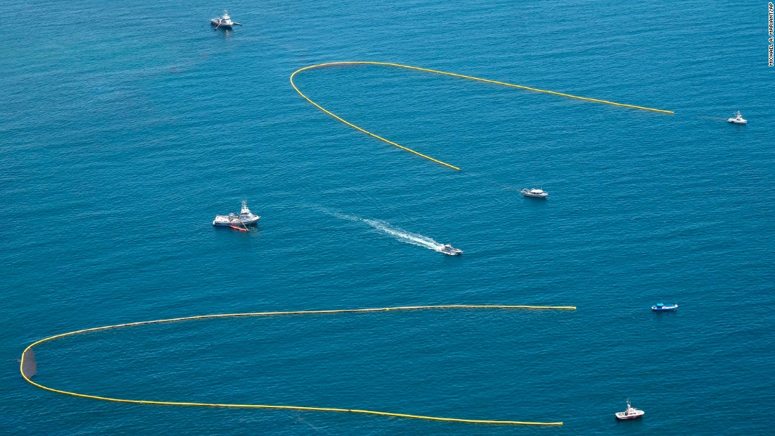Skimming Operations

PIPELINE DEMO

DEMO PIPELINE LEAK
OCTOBER 27, 2015 LEAVE A COMMENT EDIT

There has been a pipeline leak at 1234 Main.

